HCOM Objective Exercise

Please provide all names of your breakout group…should the objective team have follow-up questions. Thank you!
Names: ________________________ _____________________ ______________________ _____________________

Step One: Understanding the Desired Outcome. Review and discuss this objective’s description.

Objective Name | Objective Description
Optimize Delivery of Curriculum across the UME  Continuum | - In the spirit of catching up with our growth, this objective highlights the key motivation for developing the new office of medical education (OME) and its goal to design, deliver, manage, and evaluate our longitudinal osteopathic medical education program through continuous quality improvement. Ongoing success should be determined by college-wide identification that OME, not subparts within, serves faculty, students, and staff via efficient, seamless processes to advantage our students on their path to becoming highly sought-after graduates.

Step Two: Defining the Challenge/Problem. As a team, engage in honest discussion around “What is currently standing in the way” or “What’s the current problem and/or future problem” that is keeping us from advancing this objective?
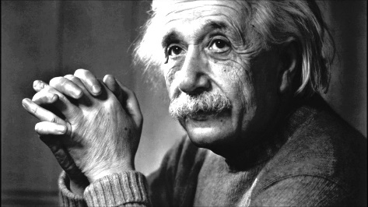
“If I had an hour to solve a problem, I'd spend 55 minutes thinking about the problem and five minutes thinking about solutions.”
- (Frequently attributed to) Albert Einstein

Step Three: Suggesting the Change Needed. Based on your team’s discussions, identify two or three new, ambitious, and potentially “game changing” initiatives that your breakout team suggests for consideration to best accomplish the objective. Please provide adequate detail of each proposed change initiative for the Objective Team to consider:

- Proposed Change Initiative #1:
After completion, PLEASE email this entire template to AFaulkner@LBLStrategies.com

- Proposed Change Initiative #2:

- Proposed Change Initiative #3:

